**LockedMe Project**

**Name: Tanmay Malpure**

**Introduction:** This program first display the Welcome message with following options following option

**If the user select more options it will show the following options**

1. Add a file

2. Delete a file

3. Search for a file

4. Navigate to main context.

**Sprints planned and the tasks achieved**

To complete this project took two sprints.

* First sprint:
  + The period of this sprint is 1 days. The tasks done in this sprint are acquiring ideas, a blueprint of the application, and designing the user interface.
* Second sprint:
  + The period of this sprint is 2 days. The tasks done in this sprint are designing the application's core features , like displaying all files, adding a file, deleting files, and searching files.

**Screenshots:**

**Searching for the file.**

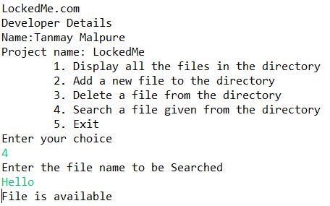

**Retrieve the files:**

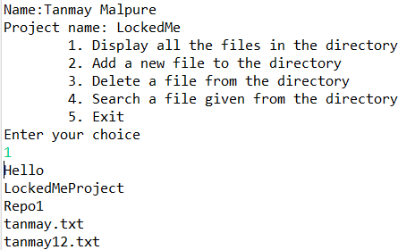

**Deleting the File:**

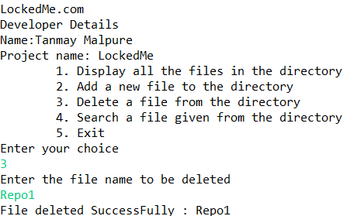

**Adding the file:**

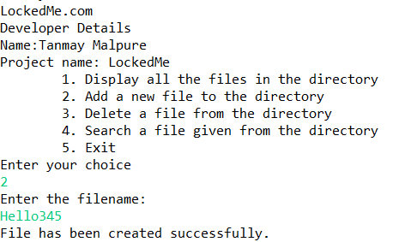

**Github Link:**

**https://github.com/Tanmay3456/LockedMe**